Meet a geriatric ‘supercouple’
Meet a geriatric ‘supercouple’
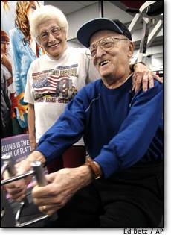
  Esther Cohen, 86, puts her arm around her husband Abe, 92, as he works out in Bay Shore, N.Y., on Sept. 30. The couple has been exercising at Bally's Fitness Center in their Long Island community for 27 years.
  He’s 92, she’s 86, and
  they’re both gym rats
  ASSOCIATED PRESS

THE BAY SHORE, N.Y., couple have been exercising at a Bally’s Fitness Centre in their Long Island community for 27 years. “We go to Bally’s seven days a week — me and my wife, of course — and we go for two hours,” Cohen said.
Experts think the Cohens show what older people are capable of, although they caution most of them not to try everything the Cohens do.
For the Cohens, exercise started at Abe Cohen’s retirement in 1975, with a suggestion by the younger of their two children, 57-year-old Martin.
As Abe recalls it, the conversation went like this: “He said, ’Dad, join the gym, you’ll have something to do.’ I said, ’Come on, I’ve never done it; why are you bothering me?”’
Even though neither Abe nor Esther had been exercisers before they joined the Bally’s club, both were used to physically hard work.
 | Esther Cohen, 86, works out next to Hector Rodriguez in Bay Shore, N.Y, on Sept. 30. |  |  |  | Abe had worked at a plant that made electrical equipment used in power plants. “I used to pick up steel sheets, cut the sheets, but I got so used to it that to me it wasn’t heavy work,” he said. His wife had worked in clothing factories, and retired a year after her husband, so she was still working at the factory while they had started at the gym.

So, which of the words you’ve learned apply to this couple?

How do you think they have managed to stay so active into their eighties and nineties?

Do you know any old people like this?

What are old geriatrics usually like in your country?

Could you see yourself getting old like the Cohens, or more gracefully?

